[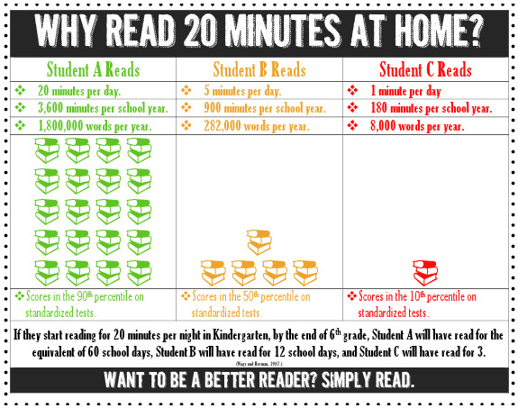](http://3.bp.blogspot.com/-eztvSiPuj6A/UXE4ZaG7iWI/AAAAAAAACso/LGZRao0XGRQ/s1600/Screen+shot+2013-04-19+at+7.28.03+AM.png)