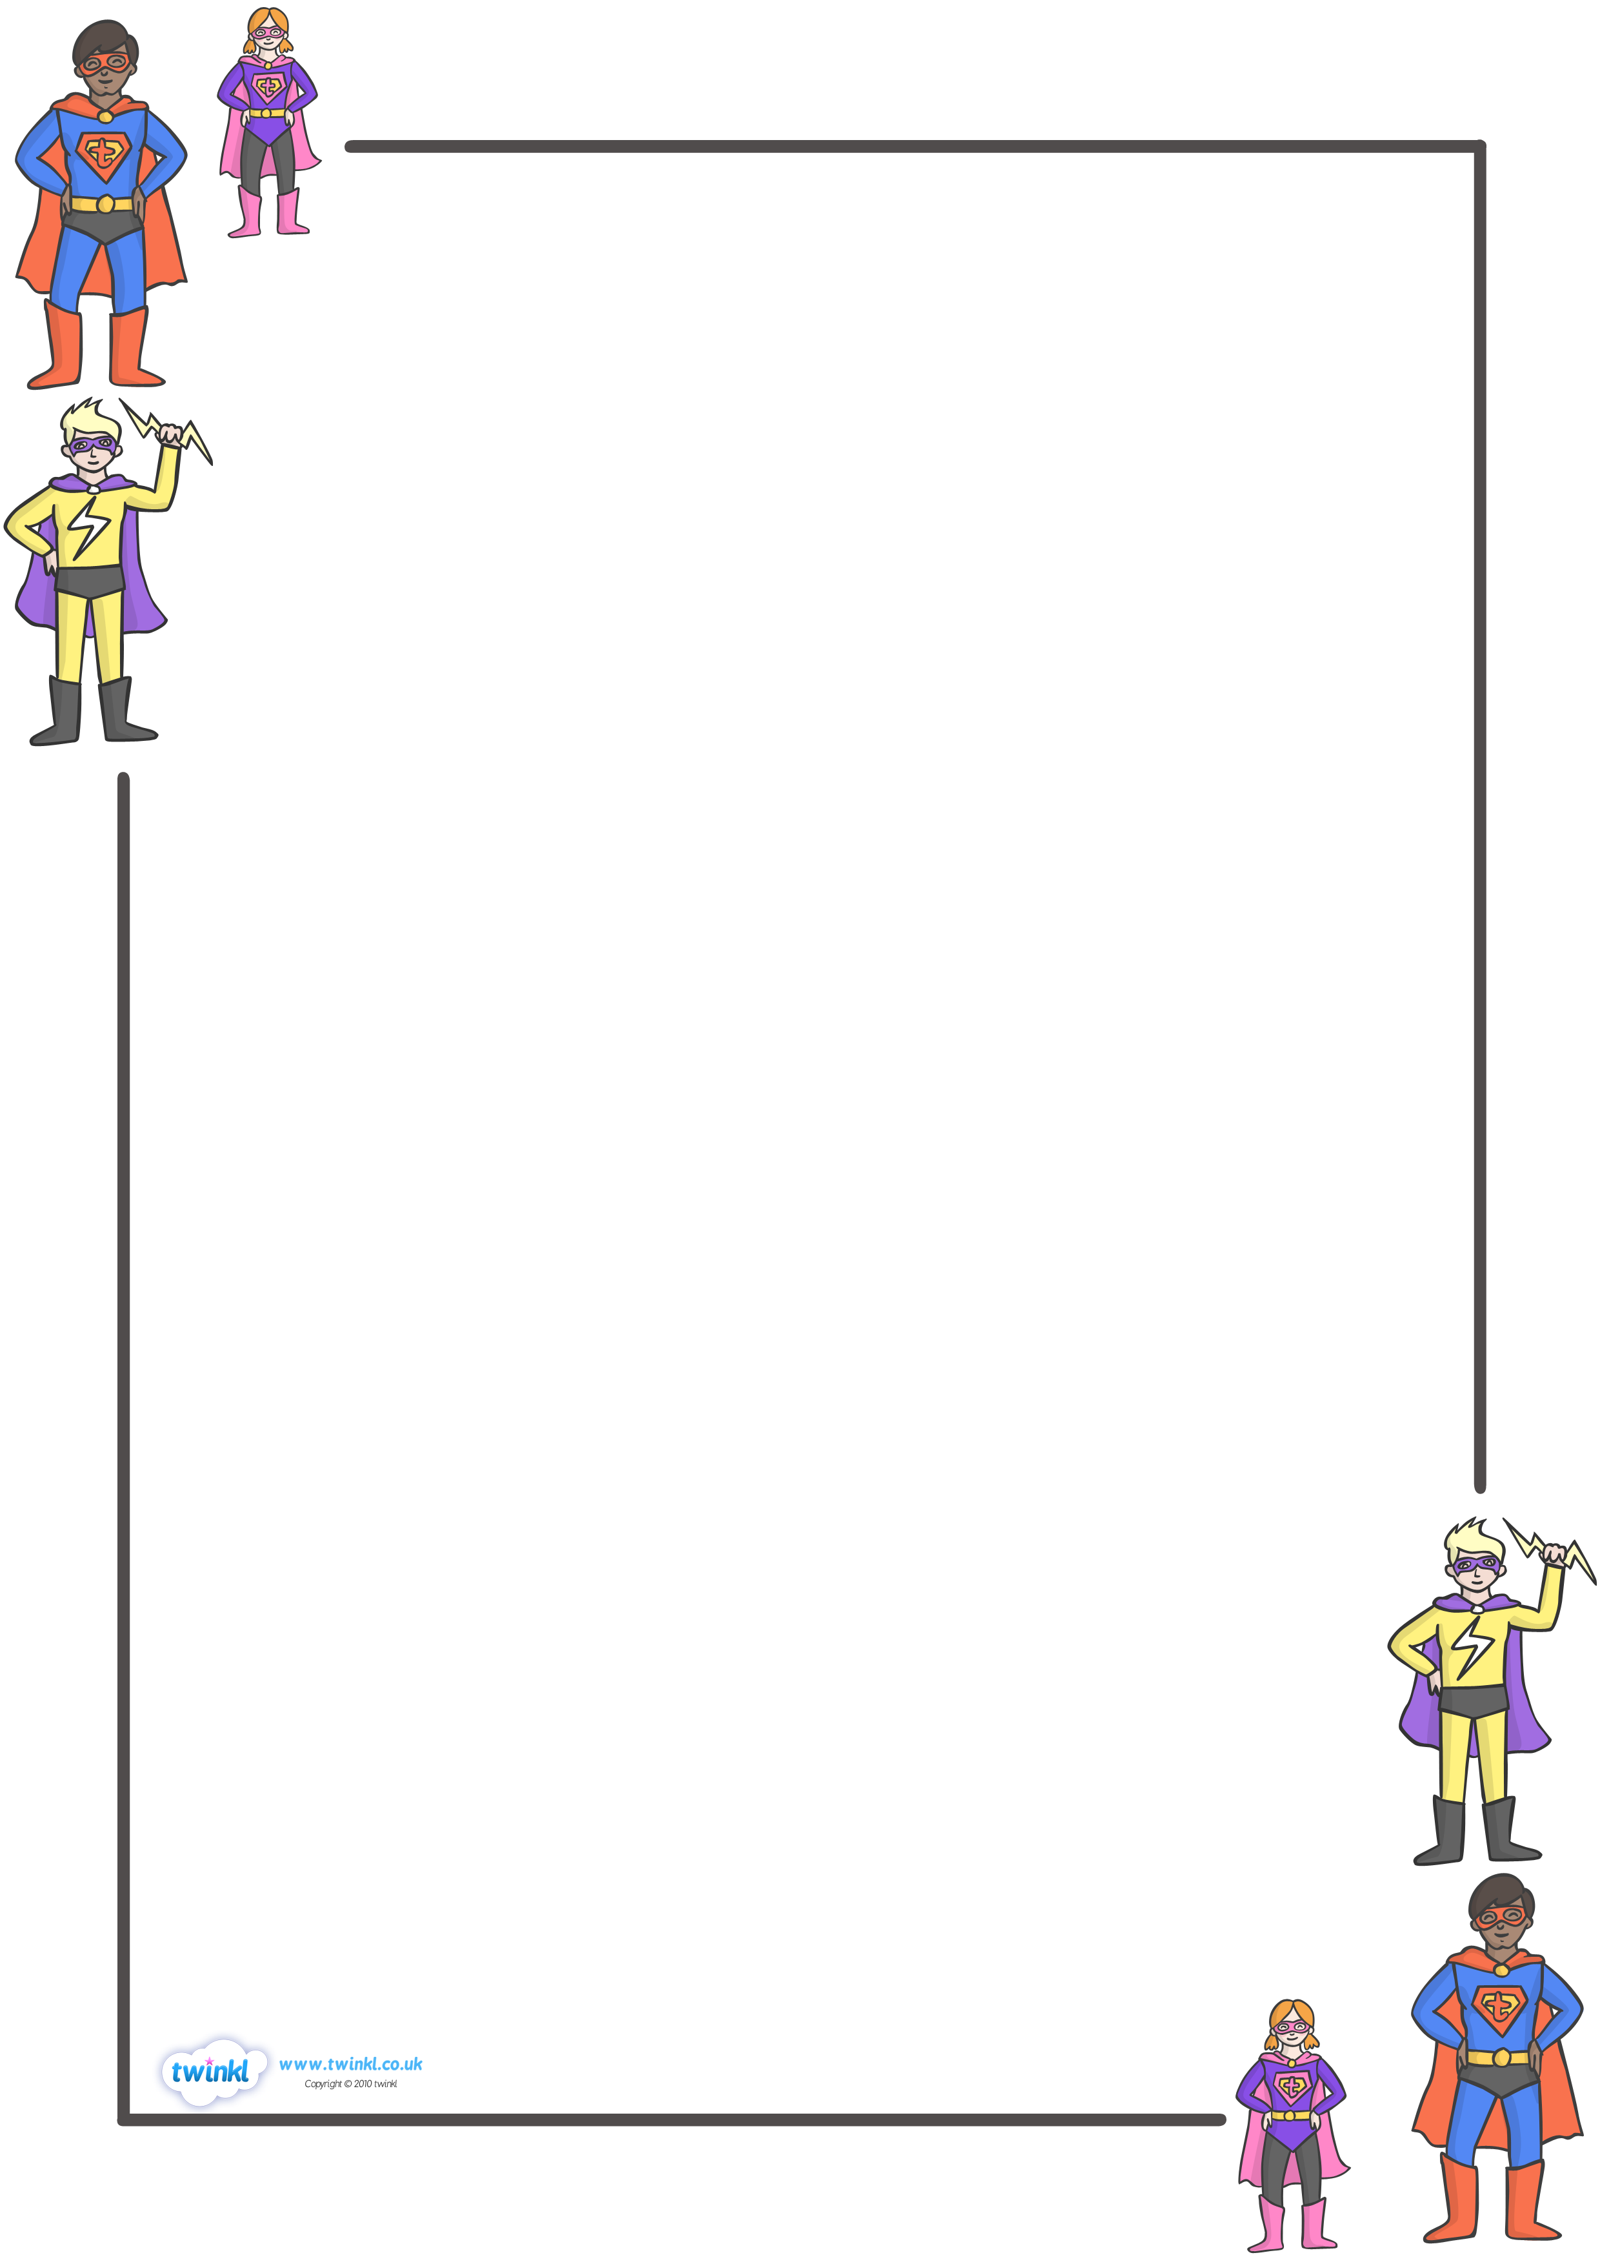

Assessment Procedures
- The voice level should be 0 during an assessment.
- Raise your hand or use a hand signal to get out of your seat of to ask a question.
- Privacy folders will be used to help prevent any cheating.
- Put your name on the assessment and wait for instructions.
- After completing the assessment, check it on last time, turn it into the basket.
- You may then read a book, write in your journal, finish any unfinished work or A.R. test.

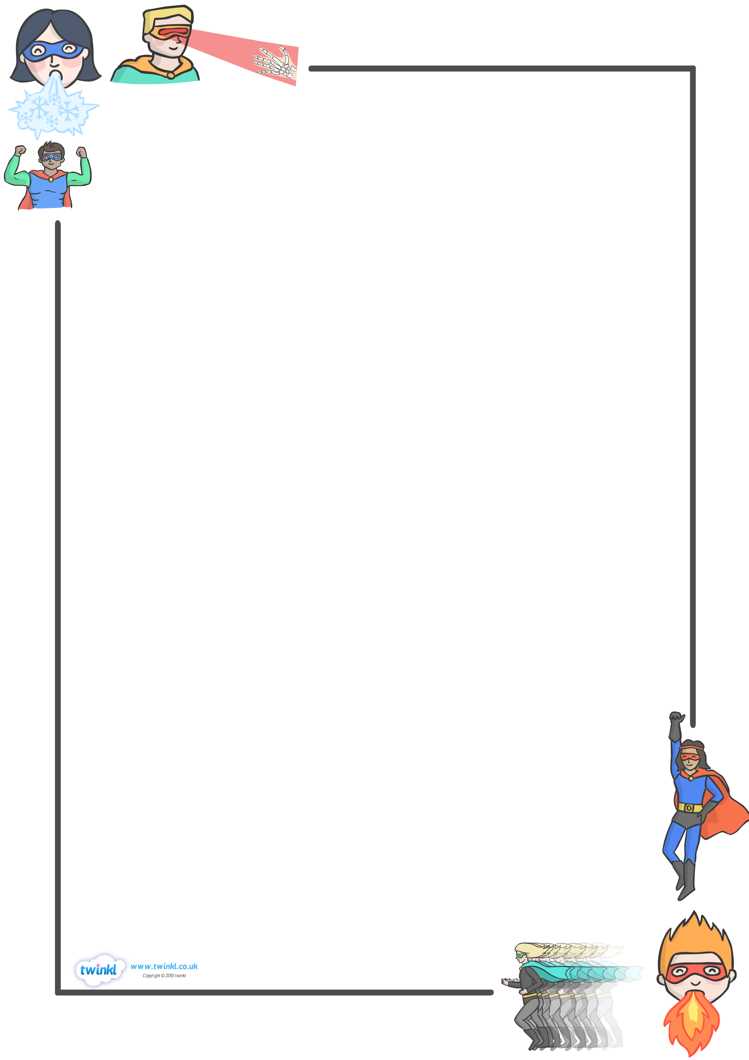
Morning Procedures
- Enter room with level 1 voice level.
- Get items out of book bag that you’ll need for the day, including homework.
- Turn in any notes for Mrs. Graf into her basket on her desk.
- Wait with level 1 voice while your team captain checks homework.
- If you are missing any part of your homework sign the oops book.

TEXT HERE
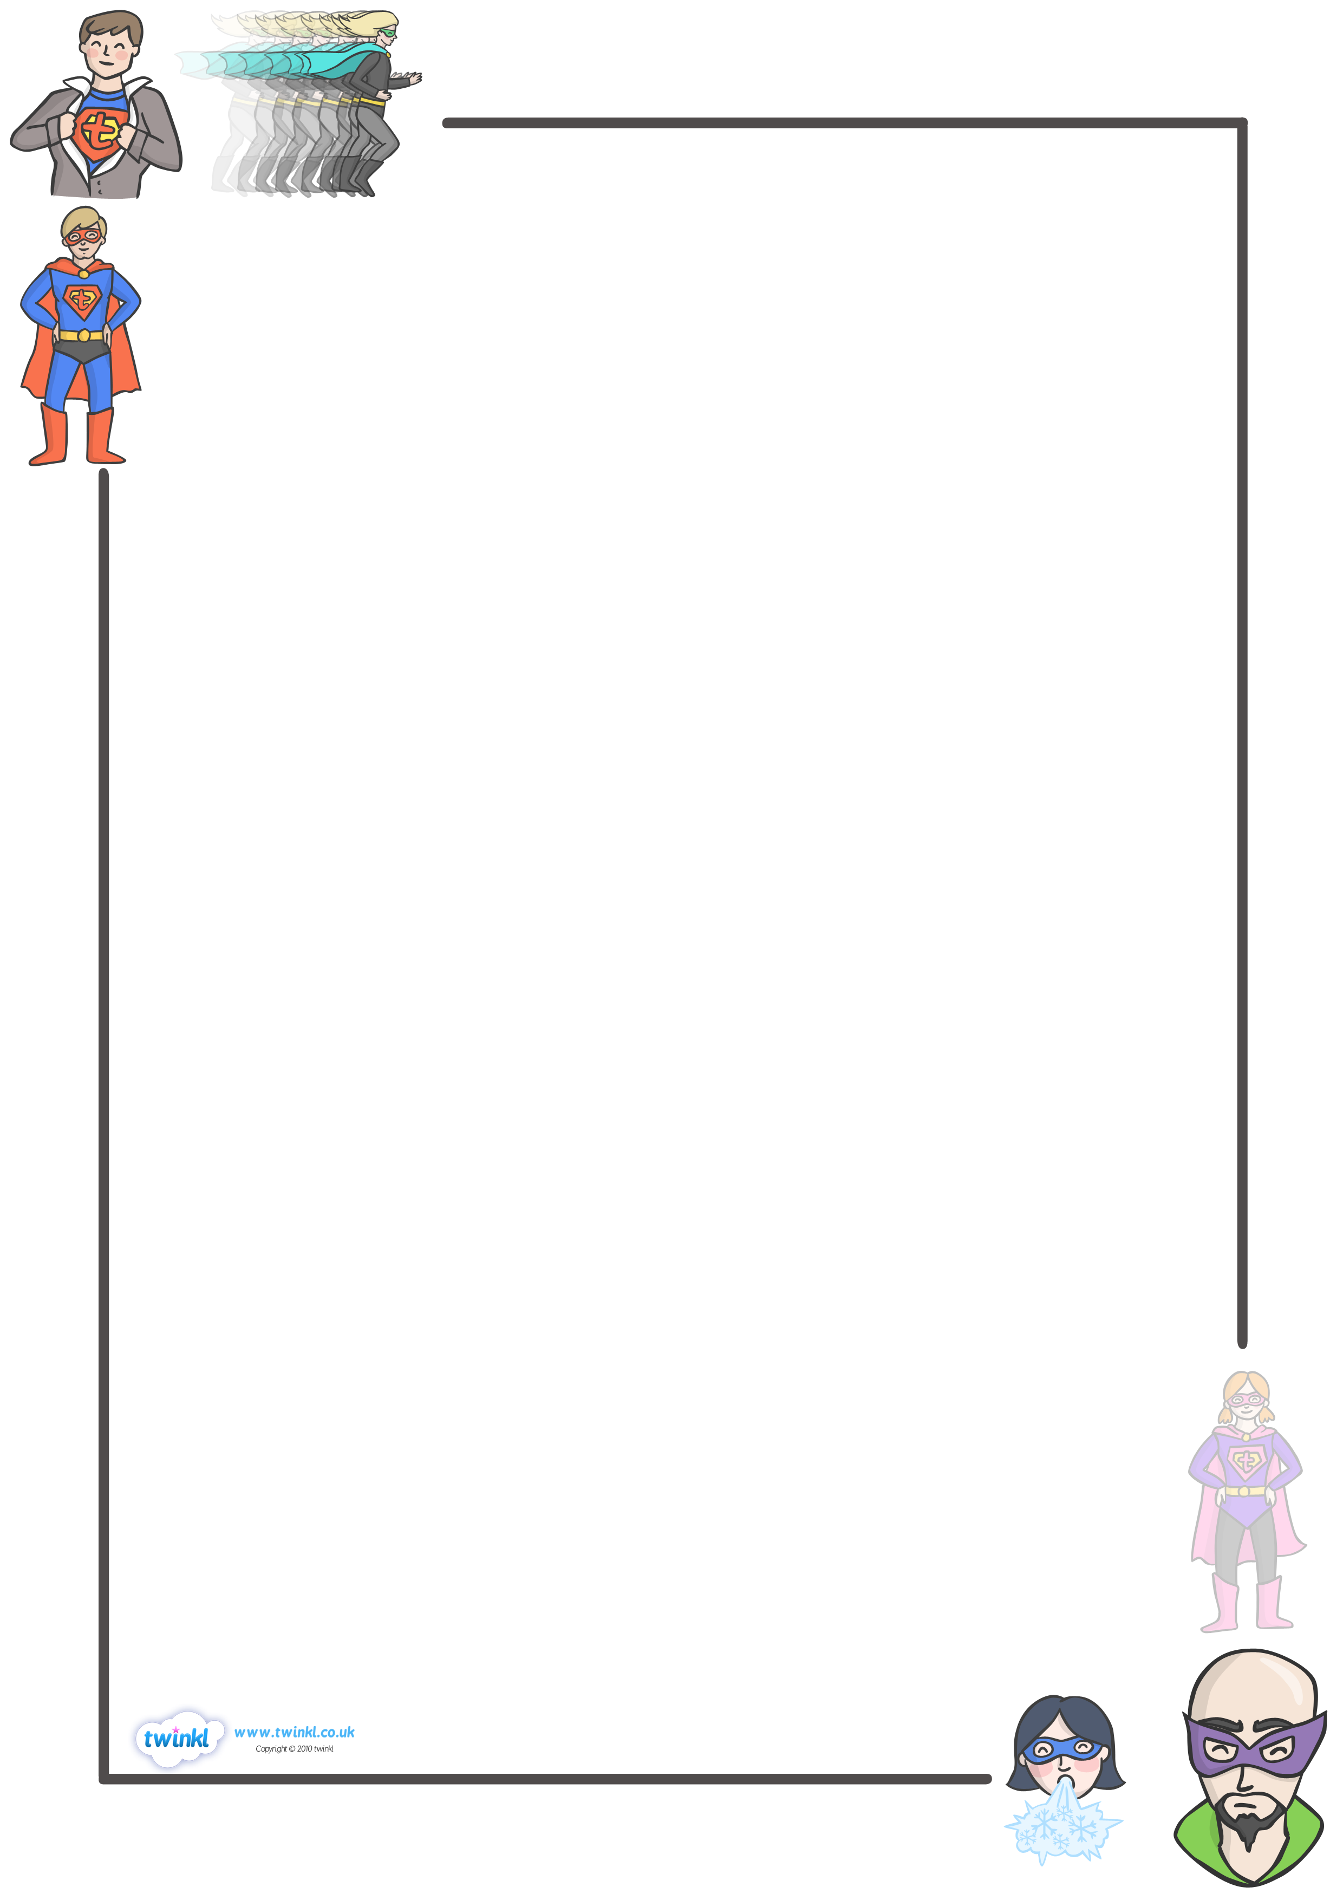
Center Procedures
- Follow the directions for each center activity.
- Stay focused on the objective of the lesson/center.
- Work at a 1 voice level.
- Work cooperatively with others if needed.
- Ask 3 people before asking Mrs. Graf for help.
- When time is up, clean up and put back any supplies you used.
- Walk quietly to your next center.

Restroom Procedures

- Mrs. Graf will dismiss you from the line to get a drink or use the restroom. If you do not need to do either, line up in the allocated spot at a level 0. Mrs. Graf will choose someone to start the quiet game.
- Socializing and playing are not permitted in the restroom.
- All students should wash their hands and dry them with one paper towel after using the restroom.

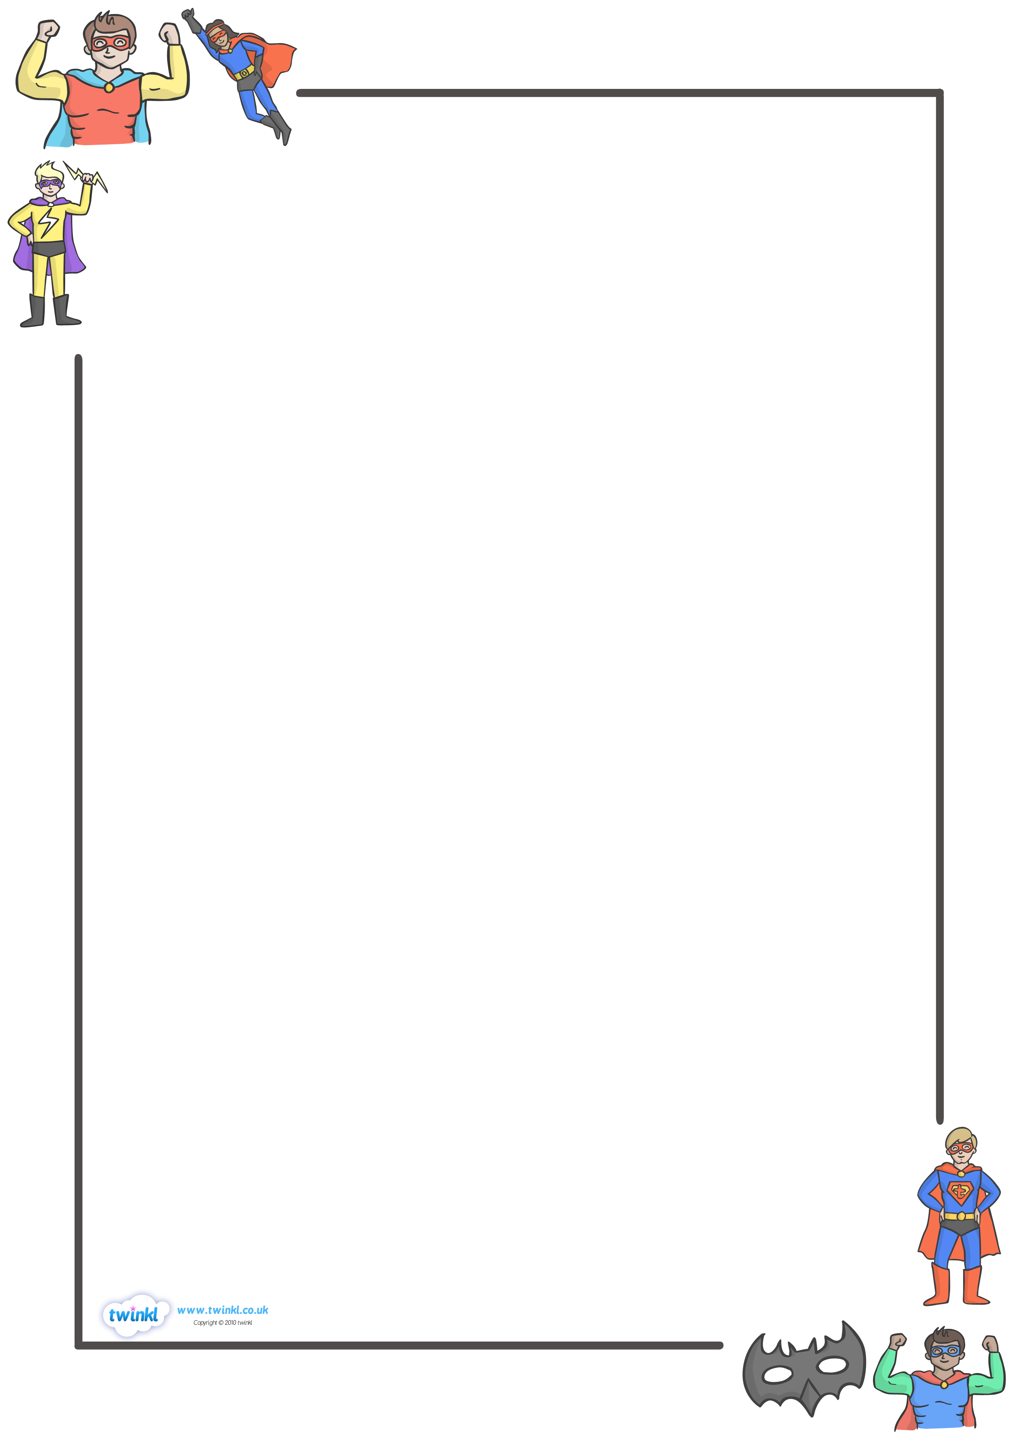
Line Up/Hall Procedures
- Clean up your desk area and get out any supplies directed by Mrs. Graf.
- When ready, sit quietly, with eyes on your team captain. When your team captain dismisses your team, stand up, push in your chair and walk to the line.
- Line up in line order quietly with a voice level of 0.
- Fold arms and look straight ahead. Leave enough space between you and the person ahead of you so you don’t step on their shoes.
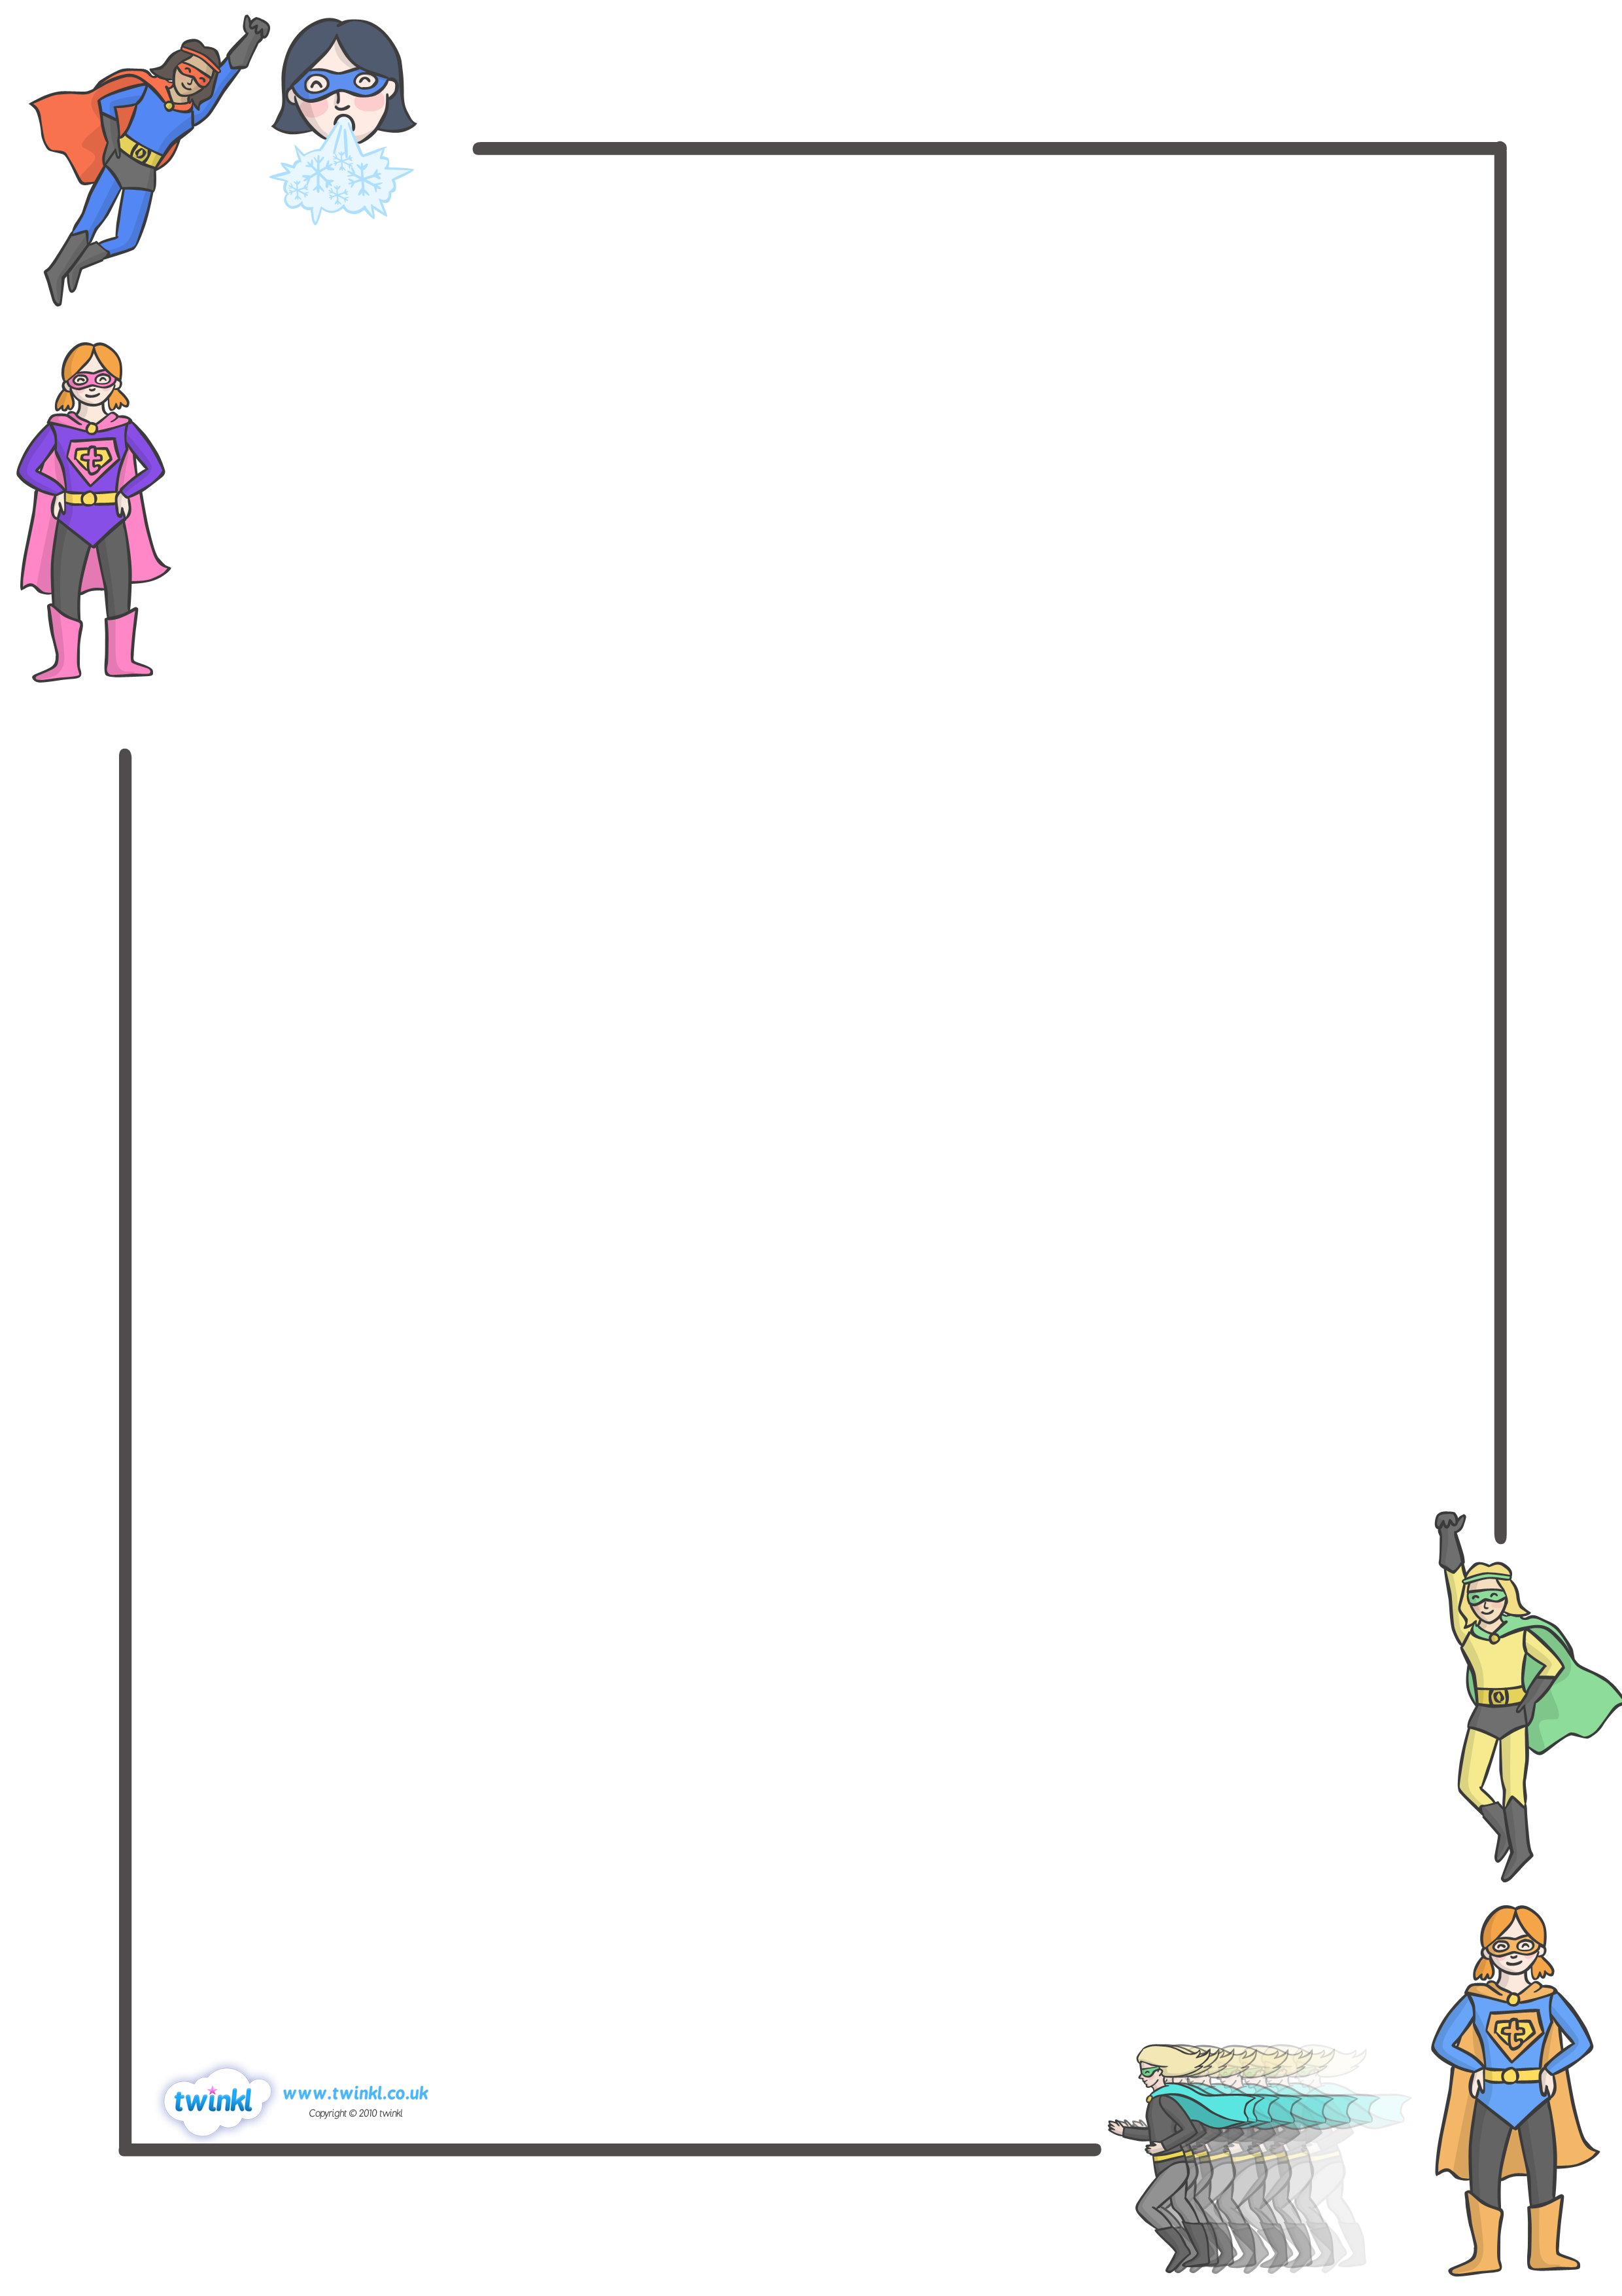
TEXT HERE
Transition Procedures
- Transition time is the time that is used to switch from one event to another.
- Listen for a signal by Mrs. Graf to make the transition.
- During this time, skip counting songs will be chanted, music will be played or a song sung.
- You are to be ready for the next event by the time the chant or song ends.

End of the Day Procedures
- When directed by Mrs. Graf, get your backpack and pack all items needed using a voice level 1.
- Don’t forget your purple take home folder with your homework!
- Place dull pencils in the can near the pencil sharpener. Clean up the floor and the area around your desk.
- This is not your social or play time.
- Kneel at your desk and look at your team captain when ready.
- Wait quietly for your team captain to dismiss you to line up in line order.

